**PROJECT TOPIC: EVENT RECOGNITION USING MACHINE LEARNING**

**Group No. :27**

**Project Group Members:**

1. Nitika Garg (Sec-G./161500365 ) **2.** Prateek Verma (Sec-A./161500405)
2. Surbhi Agarwal(Sec-A./161500574.) **4.** Sarthak Agrawal (Sec-G/161500486)

**Project Supervisor:** Mr. Sandeep Rathore, Assistant Professor

**About the Project:**

This project aims to recognize various events using machine learning. It will deal with two major phases:

1) Object recognition

2)Activity recognition.

An object is any distinguishable entity. Events, by nature, are defined by the interaction among key entities, including humans and objects [1]. Therefore, identifying such entities in an image is a key step towards event understanding. The activities can be like swimming,cooking,running,etc. In our project the model is trained using machine learning algorithms. The basic steps involved are: framing,feature extraction,pooling. Indemnifiable objects are detected, they are pre-processed and feature reduction is applied to reduce the size. The object recognition finds out the objects in the input image for example, suppose input image is a bicycle. Then the object recognized as bicycle and the second phase i.e. Activity Recognition finds out the activity is being done with respect to the object bicycle i.e. cycling.

**Motivation:**

The transfer and exchange of media, specially images and videos is increasing day by day. The social networking sites, CCTV coverages, etc contributes significantly in this. Therefore, it is necessary to analyse them in order to extract information. Event recognition is not a new story in computer vision. However, most existing efforts are devoted to recognizing events from videos. Our aim is to predict the events in an effective manner in less computational time.

Application areas of our project are: Defence surveillance, Business Analysis, Healthcare monitoring, etc.

**Project Planning:**

We have planned the project according to the dates mentioned in the Gantt Chart below and hence can be observed through the timeline below. Our final aim is to improve the accuracy of our project by using different algorithms.

**Gantt Chart**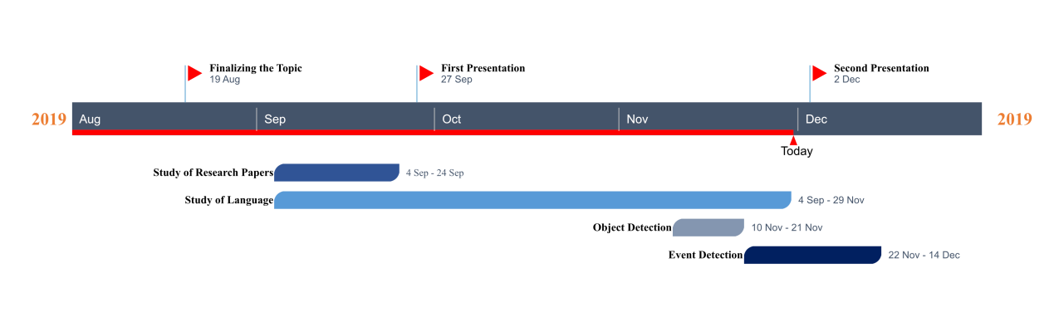

**Tools required:**

* **Hardware Requirements:**

1. GPU (4 GB atleast)

* **Software Requirements:**

1. Python IDE 3.7

**References:**

[1] Xiong, Y., Zhu, K., Lin D. & Tang, X, “Recognize Complex Events from Static Images by Fusing Deep Channels”, Proceedings of the IEEE conference on computer vision and pattern recognition, pp. 1600-1609, 2015.

**Signature of Project Supervisor: _____________________**